Depth-First Search (DFS)
AIM:
To write a Python program to implement Depth-First Search for graph traversal.

ALGORITHMS:
- Start.
- Initialize an empty visited set.
- Visit the starting node and mark it as visited.
- Print the current node.
- Visit an unvisited neighboring node recursively.
- Continue until no unvisited neighbors remain.
- Backtrack and visit other unvisited neighbors.
- Stop when all reachable nodes are visited.

CODE:
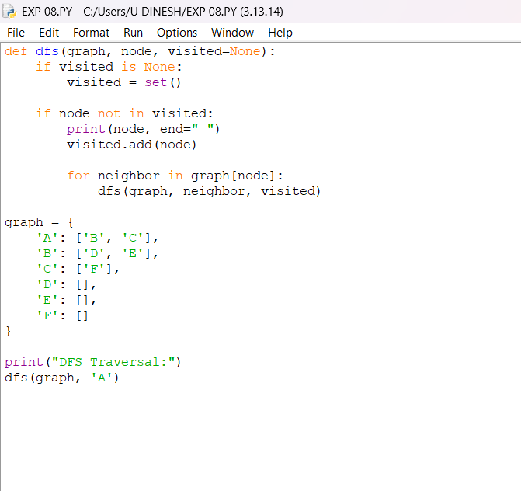
OUTPUT:
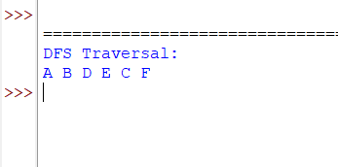

RESULT:
. Depth-First Search (DFS): The graph is traversed by exploring one path deeply before backtracking.

